# CS 255 System Design Document Template

## UML Diagrams

### UML Use Case Diagram

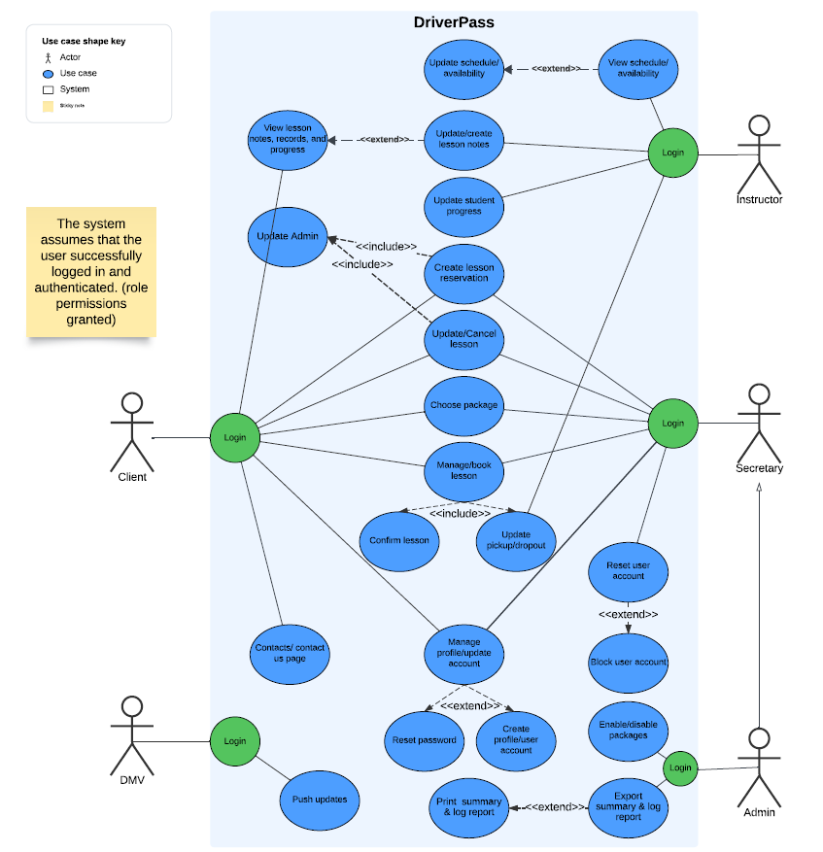

### UML Activity Diagrams

### UML Sequence Diagram

### UML Class Diagram

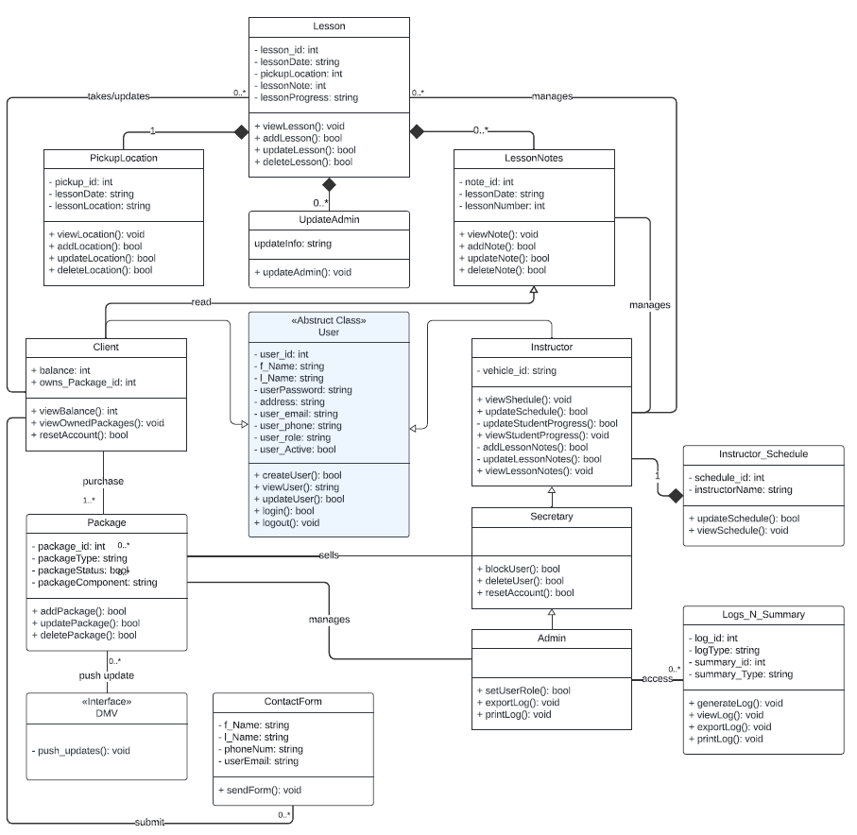

## Technical Requirements

*Hardware:*

* Mobile or static device with a fast internet connection.
* Back-end server.
* Front-end device with access to an internet browser.
* Front-end device with keyboard or touchscreen.
* Sufficient free memory space on the front-end operating device.

*Software:*

* Responsive Design to ensure the application supports various screen sizes.
* Up-to-date browsers.
* Connectivity to a relational database such as MySQL.
* API connectivity for authentication and authorization purposes.
* API connectivity to a POS system for transaction authorization.

*Tools:*

* IDE, such as Visual Studio Code or Xcode.
* Version Control System such as Git or GitHub for managing version control.
* Teams collaboration tools such as Jira or Microsoft Teams.

*Infrastructure:*

* Cloud-based web hosting server for scalability reasons, such as AWS, Azure, or GCP.
* Connectivity to a relational database such as MySQL or MongoDB.
* SSL/TLS certificates to ensure encrypted communication.